HOME PAGE - VIRAJIT.COM

- Use dark black color for text instead of grey color
- Increase the font size by a least 2 to 4 spaces to make it easy to read

_________________________________________________________________

Reduce the gap between these two sections - section 1 & 2

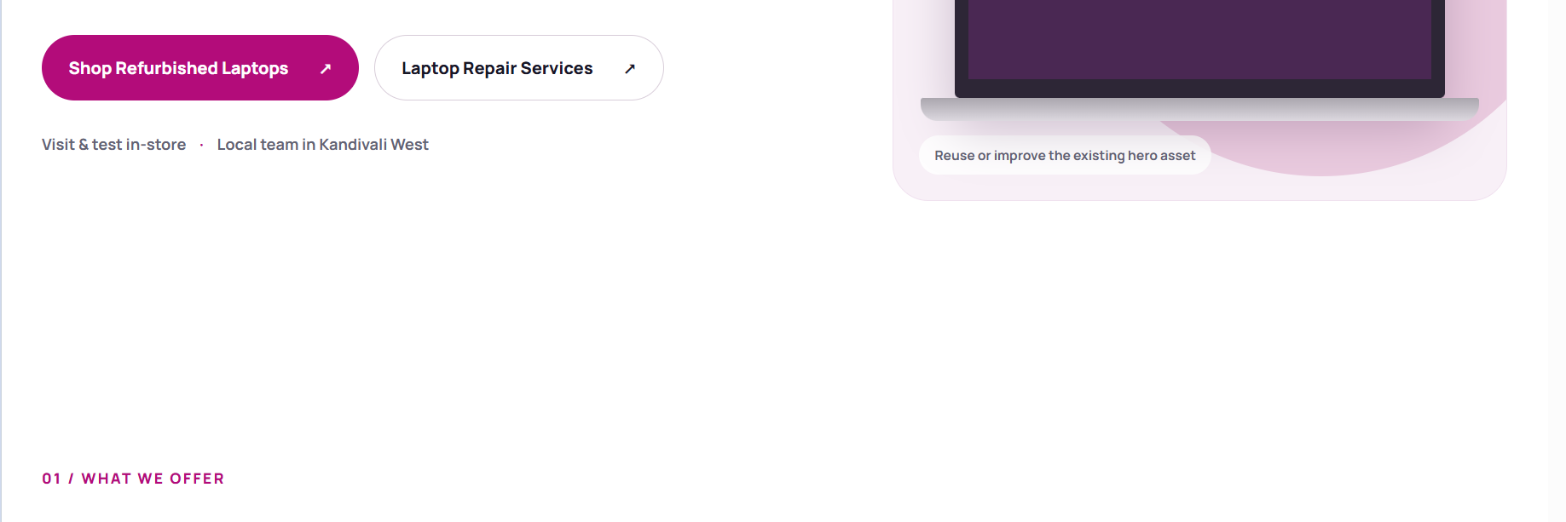

_________________________________________________________________

- Keep 4 refurbished laptops in one raw. Add 2 raws. Total 8 Laptops.
- Each laptop should have these fields only
  - Image
  - Title - Refurbished DELL Latitude 7480 | Intel Core i5 6th Gen | 14" FHD
  - Bubbles for - Intel Core i5 6th Gen | 8GB RAM | 256GB SSD
  - Price - ₹ 42,999₹ 79,99946% off
  - Warranty Included
  - Button - View Details (pink color)

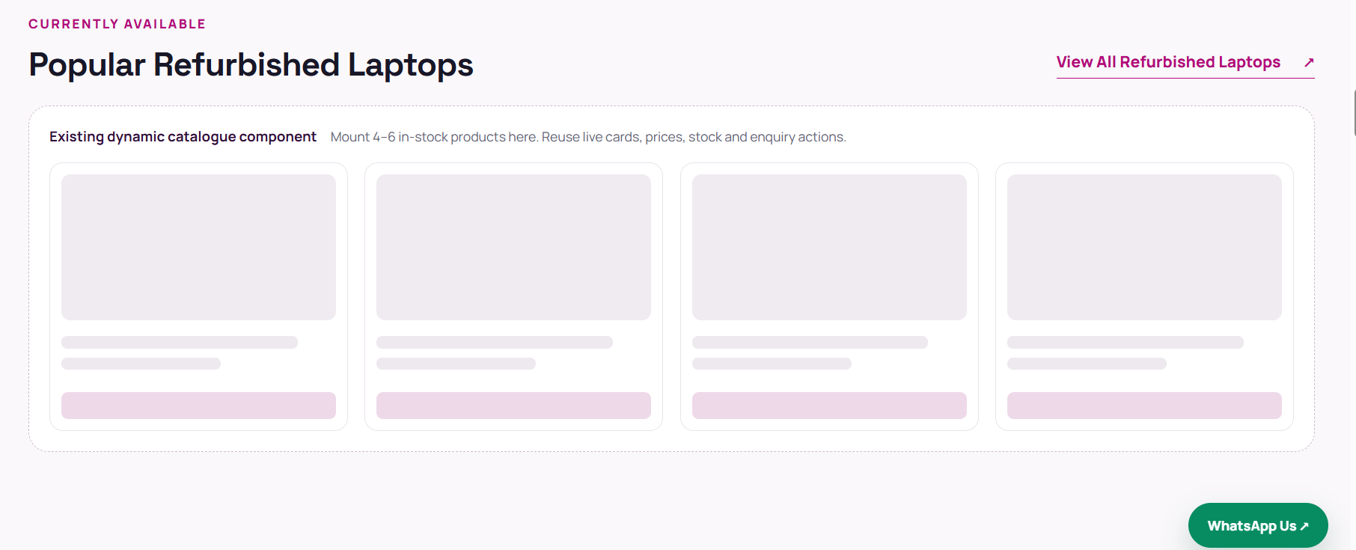

Reference image 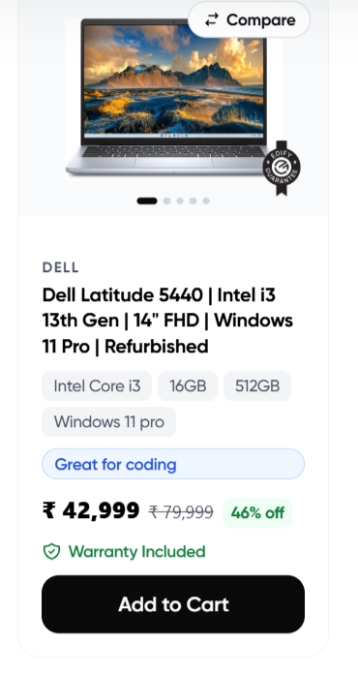

_________________________________________________________________

Use following text for Brand Association

Official dealer and authorised partner for leading laptop and printer brands.

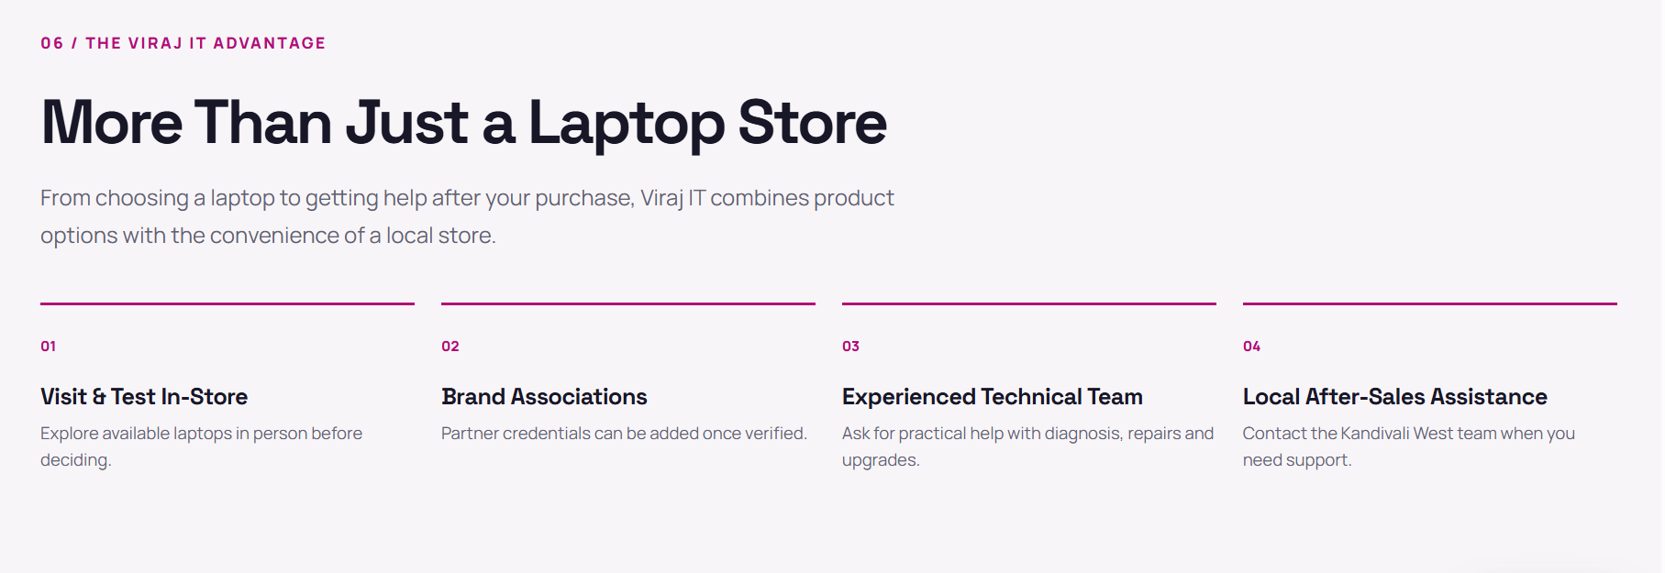

_________________________________________________________________

Update these reviews here and pick up the customer photos from home-page folder

Google Review link: https://g.page/r/Ca3LSSyVus64EAI/review

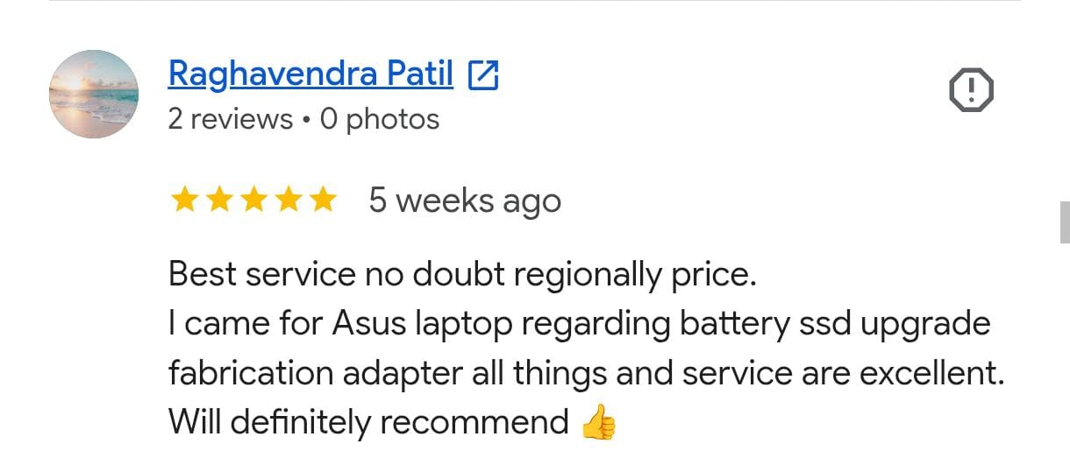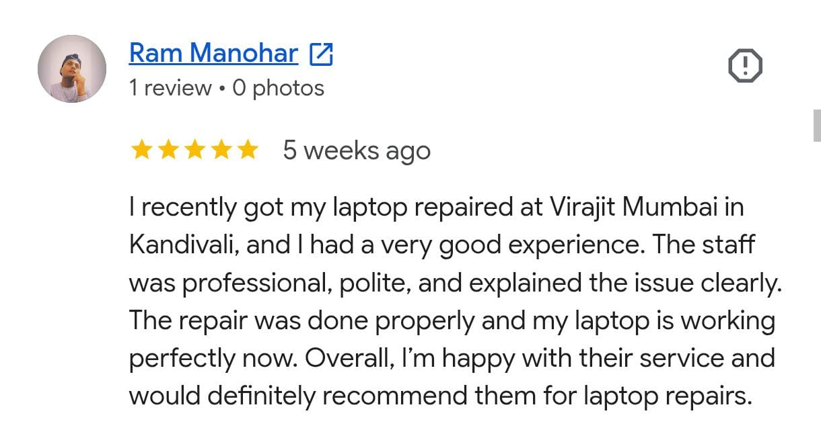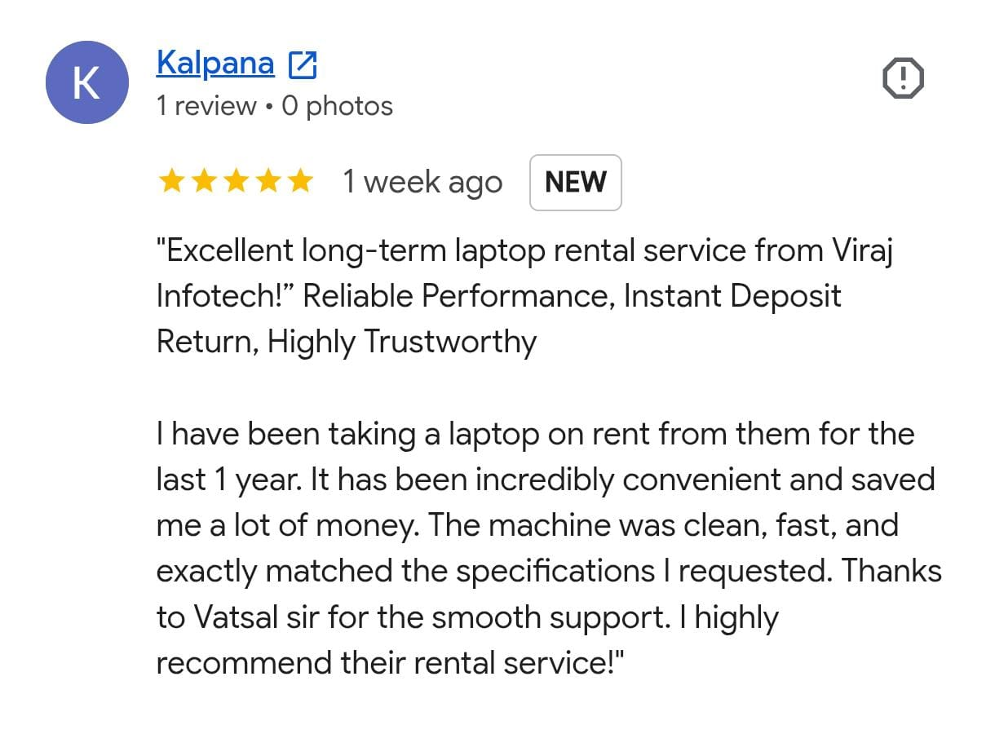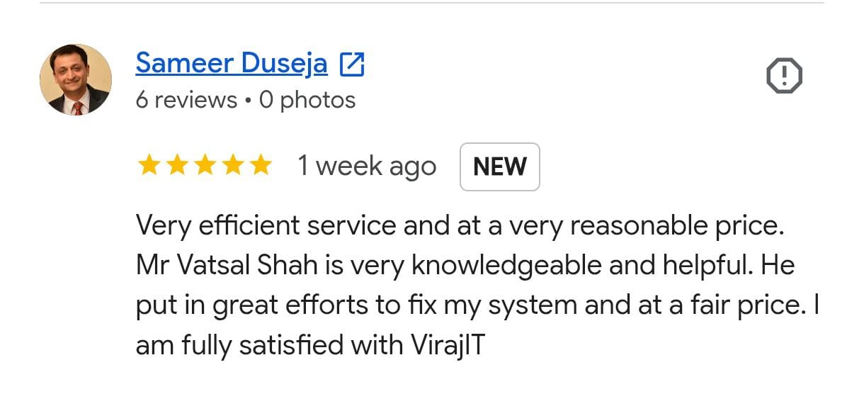

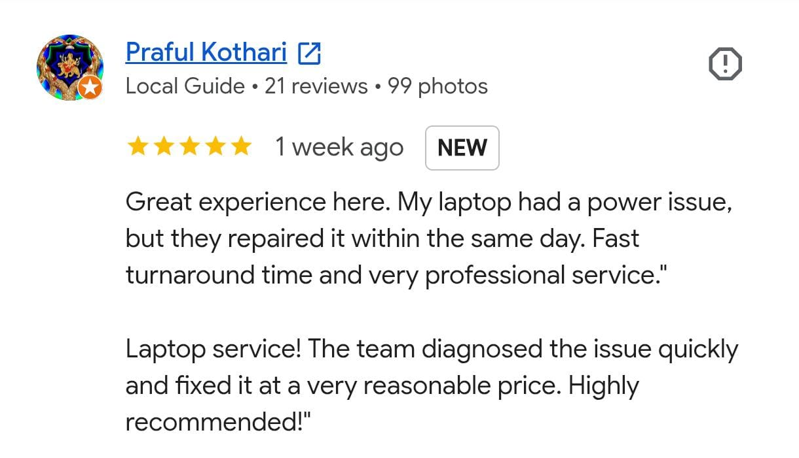

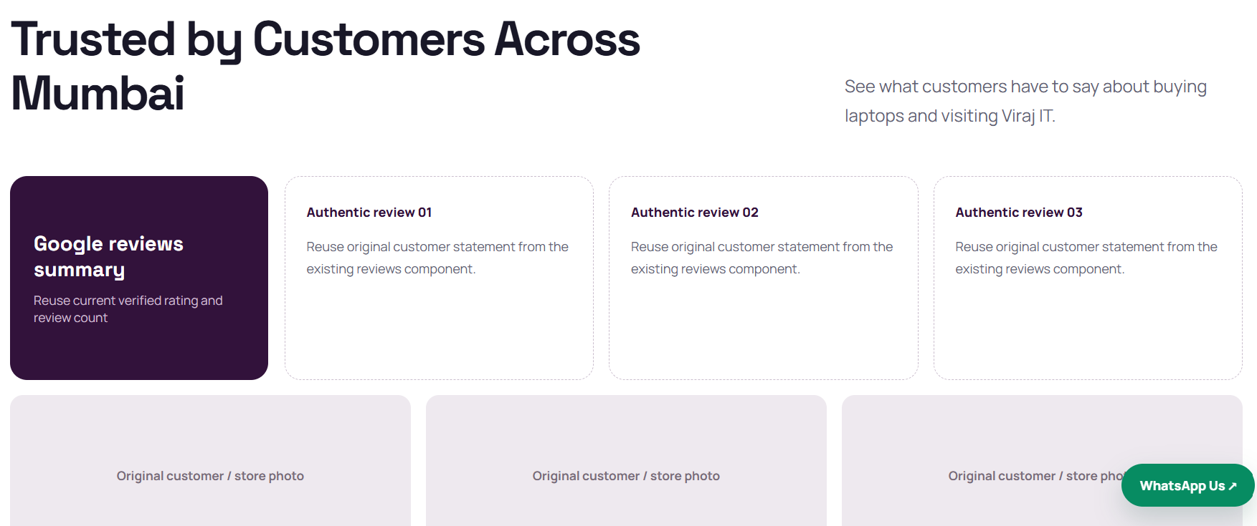
Update These Details

Visit VirajIT (Viraj Infotech).......

Store Address
Shop no 31, Ground Floor, Shanti lal, Shreeji Darshan Building, Shantilal Modi Road,Near Bata Showroom, Kandivali, Bhagat Colony, Kandivali West, Mumbai, Maharashtra 400067.

Google Map Link
https://maps.app.goo.gl/Ct4ewUbax8xj9UaB8

Embedded Map link:
<iframe src="https://www.google.com/maps/embed?pb=!1m18!1m12!1m3!1d3767.8641568220833!2d72.84362103670237!3d19.201134708472352!2m3!1f0!2f0!3f0!3m2!1i1024!2i768!4f13.1!3m3!1m2!1s0x3be7b7625f004dc9%3A0xb8ceba952c49cbad!2sVirajIT%20Mumbai%20%7C%20Laptop%20Repair%20and%20Refurbished%20Laptop%20Store!5e0!3m2!1sen!2sin!4v1792837979716!5m2!1sen!2sin" width="600" height="450" style="border:0;" allowfullscreen="" loading="lazy" referrerpolicy="strict-origin-when-cross-origin"></iframe>





